**Milestone 1 - Group 1**

**1.Subsystem Overview**

Subsystem E is the PX amplifier and filter subsystem, the subsystem is to function as a amplifier, taking the output from Subsystem D and amplifying it to a powerful signal that can be applied to the radio’s antenna and broadcast over a significant distance. Design of the subsystem consists of four parts: driver, voltage booster, power amplifier, and filter. With the cooperation of the four components, the design will produce the correct output corresponding to its input. 65tr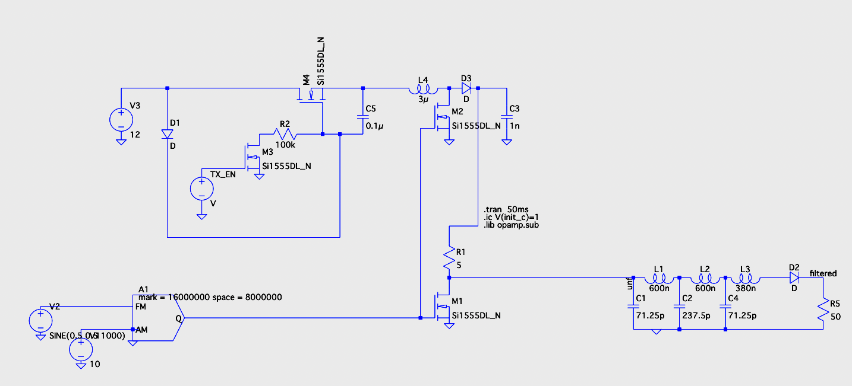

**2.Input / Output Signals**

Apart from the common 12 and 5 volt Vdd and Gnd there are 3 important input/outputs.

* TXEN: This signal turns the subsystem circuit on and off.
* PA_IN: This signal is the input signal which needs to be amplified
* PA_OUT: This is the output signal which is directed into the antenna.

**3.Subsystem Design:**

The subsystem is split into 4 parts:

* The driver which is a bootstrap circuit
* a voltage booster
* a class D amplifier
* a fifth order low pass filter.

The specific selection of parts with their pros and cons are in the appendix.

**3.1. Driver**

It is a standard bootstrap circuit. Its primary function is to receive the TX_EN enable signal specified in ICD, which indicates whether the radio is in receive mode or transmit mode. In receive mode, the subsystem is off, while in transmit mode the circuit processes the signals to amplify it.

In the optimized design. There is a 1000 ohms resistor R2 , so that when the voltage goes to the switch, it will pass through the resistor first, and by ohm's law, 12v / resistance, the voltage leakage can be minimized since the value will be approachi

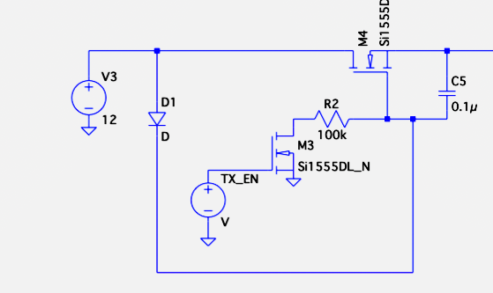

**3.2. Voltage Booster:**

Its primary function is to boost the Vdd of 12 v to 20 volts so that the output of the class D amplifier is a 0 to 20 V square wave which then allows for a peak power of 10W.

The inductor plus the voltage of the voltage supply pump the capacitor to 20V. This booster is designed with the Class D amplifier in mind and has a duty cycle of 50%. This is inline with the FM signal too.

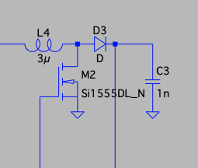

**3.3. Class D amplifier and filter**

In the design of the power amplifier, the class D Amplifier model has been selected for implementation. However, the creation of high frequency harmonic distortions during amplification poses a challenge, transforming the input sine signal into a square wave output. The low-pass filter serves to attenuate the high-frequency harmonics produced during amplification, thereby restoring the original signal fidelity. The choosing of a low-pass filter ensures an accurate amplification of signals despite the harmonic distortions of the class D Amplifier.

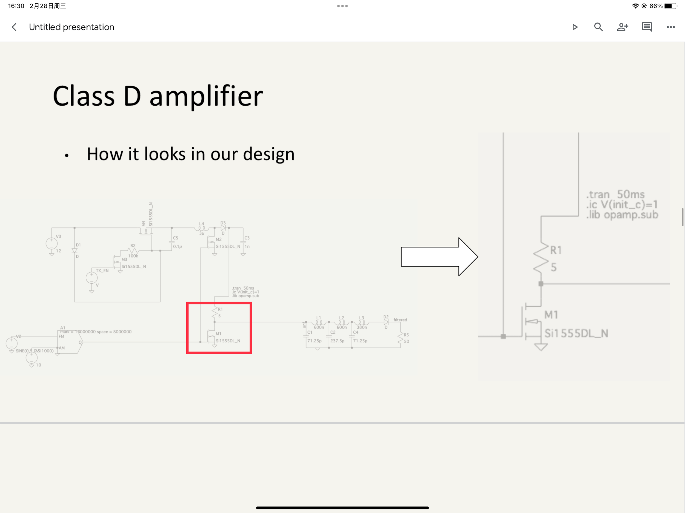

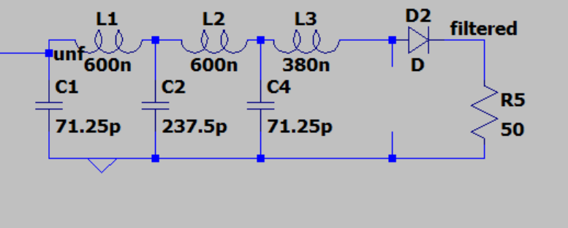

**Appendix:**

Figure 1. Subsystem overview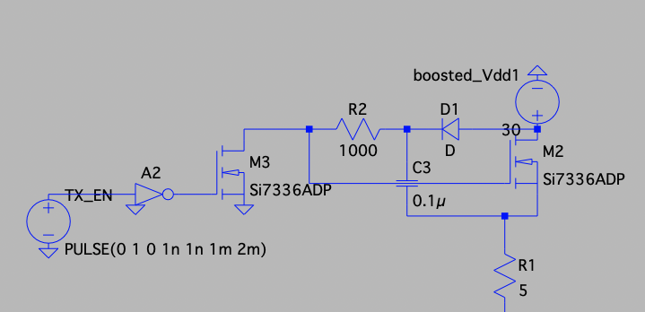

Figure 2. Driver design

Figure 3. Voltage Booster design

Figure 4. Class D Amplifier and filter design

Table 1:

| Op amp for amplifying input single to power mosfet. | <https://www.digikey.ca/en/products/detail/texas-instruments/TLV3541IDBVR/6566102>   * Signal opamp * Its rail to rail very good   <https://www.digikey.ca/en/products/detail/texas-instruments/LM4562NA-NOPB/1217793>   * Signal opamp it is through hole so it can be very easily tested |
| --- | --- |
| Bootstrap mosfet | <https://www.digikey.ca/en/products/detail/nexperia-usa-inc/BSH105-215/1155056>   * 0.5 threshold * 20Vdss * 4A I break down |
| Power mosfet (voltage booster and class d amplifier) | <https://www.digikey.ca/en/products/detail/diodes-incorporated/DMN3023L-7/5453119>   * 30 Vdss * 2A threshold |